**Green Society Public School**

**D-**

**Ratnanagar-7, Sauraha, Chitwan**

**First Terminal Examination-2082**

**Class: One Time: - 1 hr. F.M.: 25**

**Sub: HRHG P.M.: 09**

|  |
| --- |
| **Name: Roll No.: Sec.:** |
| **­­­­­­­­­­­­ ________________ ______________ OBT.MARKS:**  **INVIGILATOR EXAMINER** |

1. **Match the following. (5)**

Father Banana

Fruit Mother

Animal Parrot

Vegetable Dog

Bird Tomato

1. **Fill in the blanks. (4)**

F__ther Mothe__ U__cle Bro_ther

1. **Answer the following questions. (10)**
2. What is your name?

Ans:- My name is ______________________.

1. How old are you?

Ans:- I am ___________ years old.

1. Where do you live?

Ans:- I live in ________________.

1. In which class do you read?

Ans:- I read in class ______________.

1. What is the name of our Municipality?

Ans:- The name of our Municipality is _______________________________.

1. **Name the following pictures. (6)**

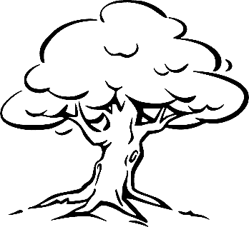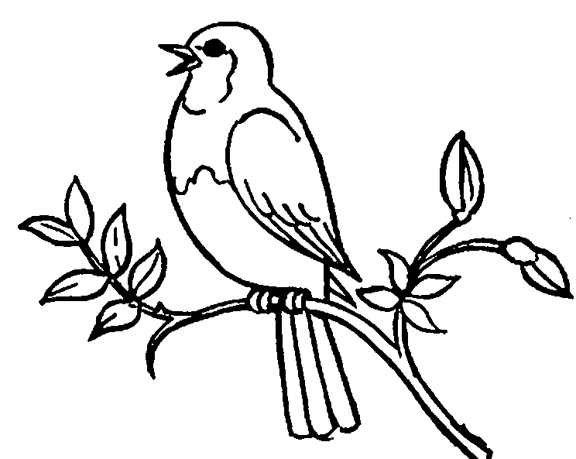

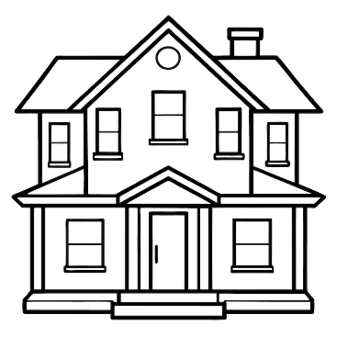

**The End**